PMC Testing Journal

# 5-Watt Tests – Insulated Cork Configuration

*\* 5W delivered into the system, 2.5W delivered into each PMC coupon*

*\* T0 and T2 on heated side*

*\*Red text: Denotes a failed test.*

## 1.1 “TC275-1 Baseline” – Test #1 – 02/13/2020

I started the test at 8:37 am and finished at 10:17 am, when the temperatures were reasonably close to steady state (no significant increase in the first decimal place for at least five minutes). I kept the door closed to prevent drafts of air. Over the duration of the experiment the door was opened a couple of times by other employees, but there was no noticeable affect at the second decimal place. There were also periodic drafts of cold air coming from the vent above me. The first two had no noticeable effect, but at 10:12 AM the vent release a significant amount of colder air and I noticed a slow decrease in temperatures at the second decimal place. Therefore, because I felt that the PMC coupons had reached “reasonably close” to steady state, I decided to end the test at 10:14:55 AM.

Unfortunately, there was a small error in my Labview software that caused the exported file to only print 2 significant figures of every string. Therefore, I lost the decimal point accuracy that was previously available. I was able to reconstruct the time vector, however, because I know the exact start time and the sampling increment. The problem with the program has been resolved, but this test will need to be redone. ~~I am also strongly considering building a shroud for the coupon such that it is less impacted by the ambient environment.~~

Additional Notes:

I noticed that a pair of thermocouples would be accurate to each other within 0.1 degrees Celsius, but when compared to another pair, they could deviate more than one degree Celsius. After testing multiple thermocouples in the same channel and moving thermocouples between channels, I concluded that the origin of the issue was not the thermocouples, but the DAQ device itself. So, I had two options: Either calibrate the DAQ channels or find channels that were similar enough to each other for this experiment. I decided to go with the simpler option first and found 5 channels that were similar enough to continue testing. I define “similar enough” as channels that are within 0.1 degrees Celsius of each other after reaching room temperature and resting over a full weekend. I chose degrees Celsius because it is equivalent to the noise that already exists on signals coming from the thermocouples and is therefore as accurate as possible. This excludes the ambient temperature reading as the exact value is not important. The ambient temperature reading is only meant to give a qualitative indication of how the temperature in the room is changing to see if it impacts the data.

## 1.2 “TC275-1 Baseline” – Test #2 – 02/18/2020

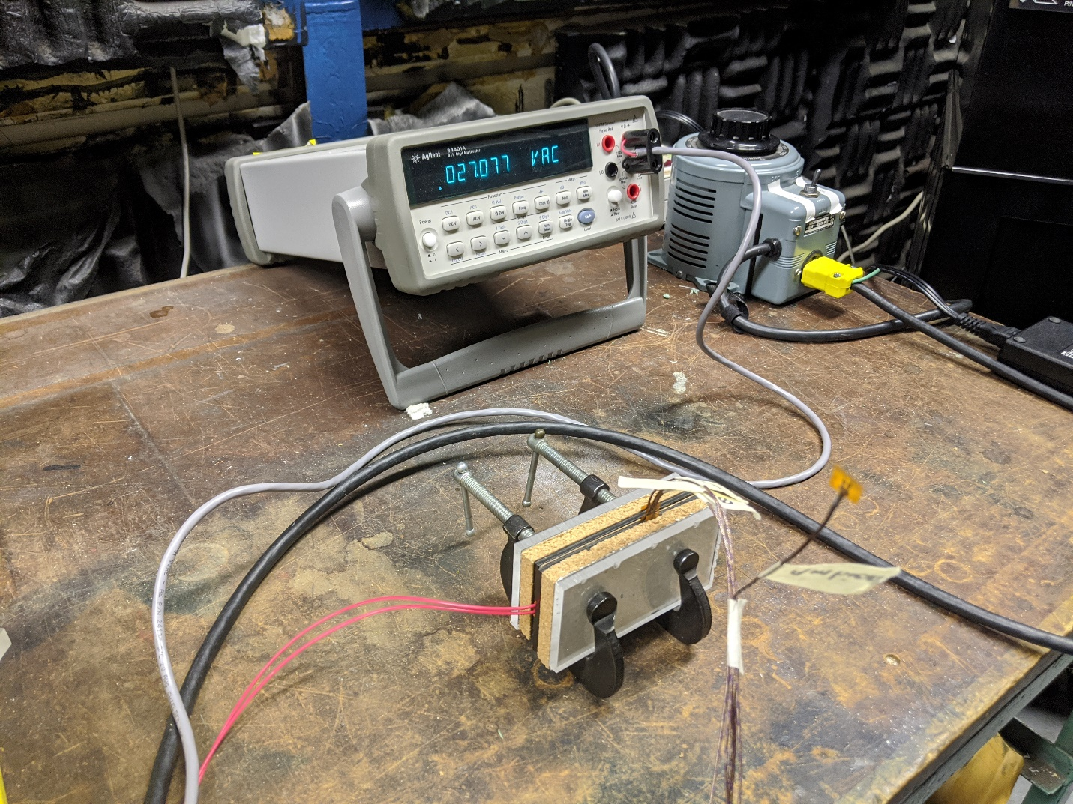Baseline Test #2 Configuration

|  |  |
| --- | --- |
| Initial Ambient Temperature | 20.43 |
| Initial Ambient Voltage | 3.7 mV |
| Start Time | 9:38 AM |
| End Time | 11:12 AM |

Baseline Test #2 Info

I waited 30 minutes for the thermocouples to stabilize their temperature readings before beginning the test. I chose 30 minutes based on the Holiday Weekend Ambient Data. After 30 minutes the T0-T4 sensors were within ~0.1 degrees of each other and took a very long time to reduce this gap further. I deemed the returns to be diminishing after this point. I located the ambient temperature sensor at a distance that would not be affected by the experiment out to second decimal place accuracy. I ran the test until the temperatures on all probes stabilized, indicating steady state conditions. I define “stabilized” in this context as the second decimal place oscillating 0.02 around some temperature for at least 5 minutes.

The data from this test is contained within the “TC275-1_Baseline_5W_Test_#2” files.

## 1.3 “TC275-1 YSH60” – 02/18/2020

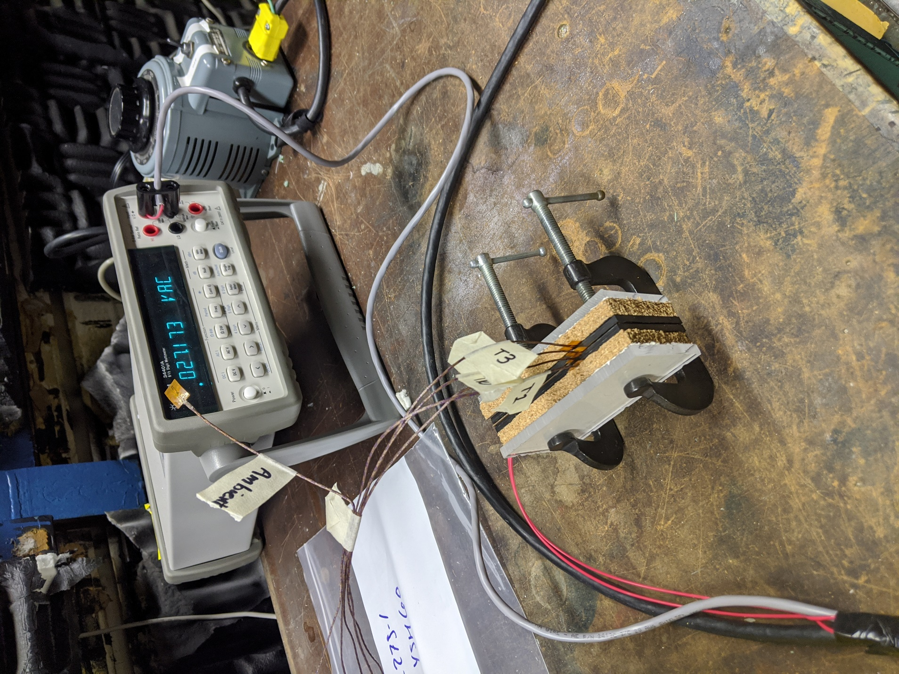TC275-1 YSH60 Configuration

|  |  |
| --- | --- |
| Initial Ambient Temperature | 20.42 |
| Initial Ambient Voltage | 3.6 mV |
| Start Time | 12:28 PM |
| End Time | 1:55 PM |

TC275-1 YSH60 Info

I changed the configuration for this test slightly so that the wires were not pulling down on the test apparatus. I repeated the procedure from Section 1.2 for this test. Cold air started entering the room slowly for the last few minutes of the test.

The data from this test is contained within the “TC275-1_YSH60_5W_Test” files.

## 1.4 “TC275-1 YSH80” [T2 Failure] – 02/18/2020

This test utilized the same procedure as section 1.2. Unfortunately, there was a failure with thermocouple T2 just before true steady state. I am including the data in case it is still useful.4

|  |  |
| --- | --- |
| Initial Ambient Temperature | 18.80 |
| Initial Ambient Voltage | 3.8 mV |
| Start Time | 2:49 PM |
| End Time | 4:21 PM |

TC275-1 YSH80 Info

The data from this test is contained within the “TC275-1_YSH80_5W_Test” files.

## 1.5 “TC275-1 YSH80” Test #2 – 02/19/2020

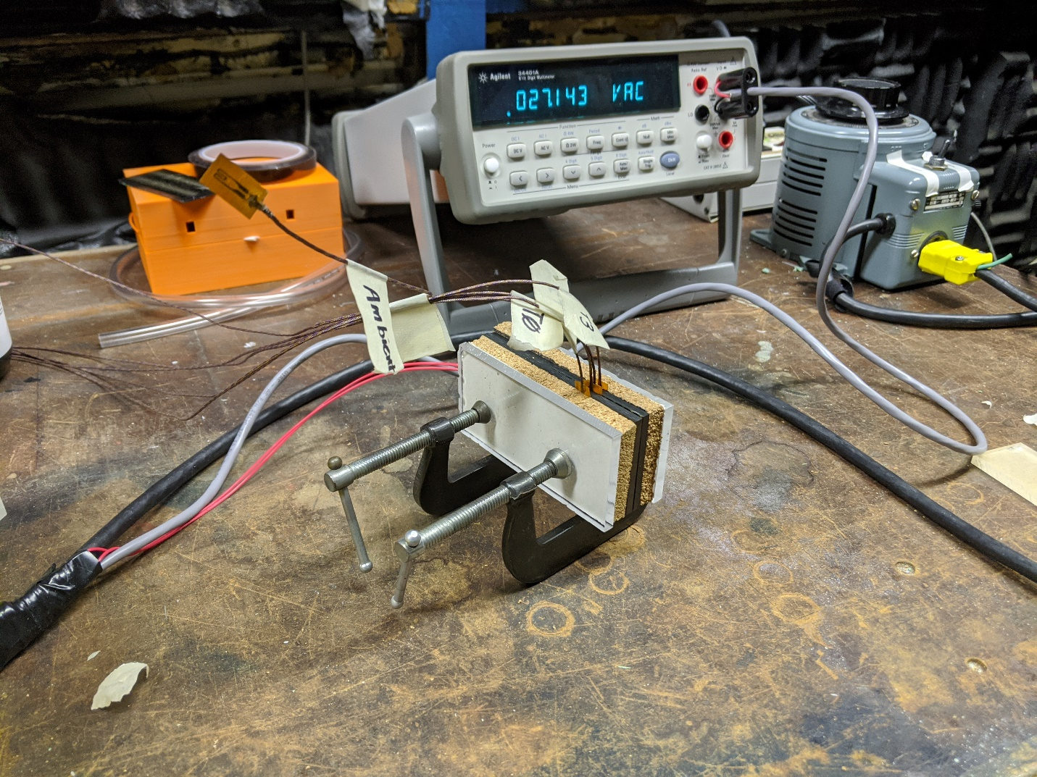

I switched thermocouple T2 from channel 15 to channel 11 which was the next best option in terms of precalibrated slots. Section 1.2 procedure used.

|  |  |
| --- | --- |
| Initial Ambient Temperature | 16.75 |
| Initial Ambient Voltage | 3.8 mV |
| Start Time | 8:17 AM |
| End Time | 9:48 AM |

TC275-1 YSH80 Test #2 Info 

The data from this test is contained within the “TC275-1_YSH80_5W_Test_2” files.

## 1.5 “TC275-1 YSH90” – 02/19/2020



I noticed a 0.2 ambient temperature difference between the starting temperatures of the thermocouple pairs at the start of this test. Calibration drifting? Material differences? Section 1.2 procedure used.

|  |  |
| --- | --- |
| Initial Ambient Temperature | 16.20 |
| Initial Ambient Voltage | 3.8 mV |
| Start Time | 10:34 AM |
| End Time | 12:00 PM |

TC275-1 YSH90 Info